# A logo of a company Description automatically generatedSri Lanka Institute of Information Technology

# SE3050 – User Experience Engineering

# Milestone 05: Prototype

**Group:** Native Coders

IT21118340 Kumarathunga S. A. D. S.

IT21291364 Rashen W.G.M

IT21267772 Kumanayake I. A.

IT21388934 Siriwardhana S.M.R.R.

**Prototypes**

## Screenshots of prototype

IT21118340: Student Management

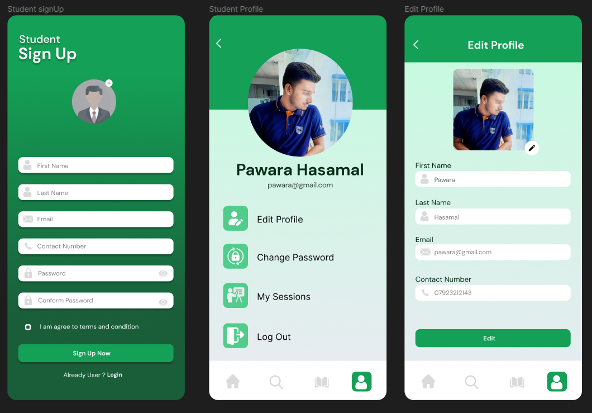Student Management – Student Signup, Student Profile, Edit Profile

IT21118340: Study Material Management

Study material Management – Search study materials, View study materials by category, View and Download study materials. – (User role: Student)

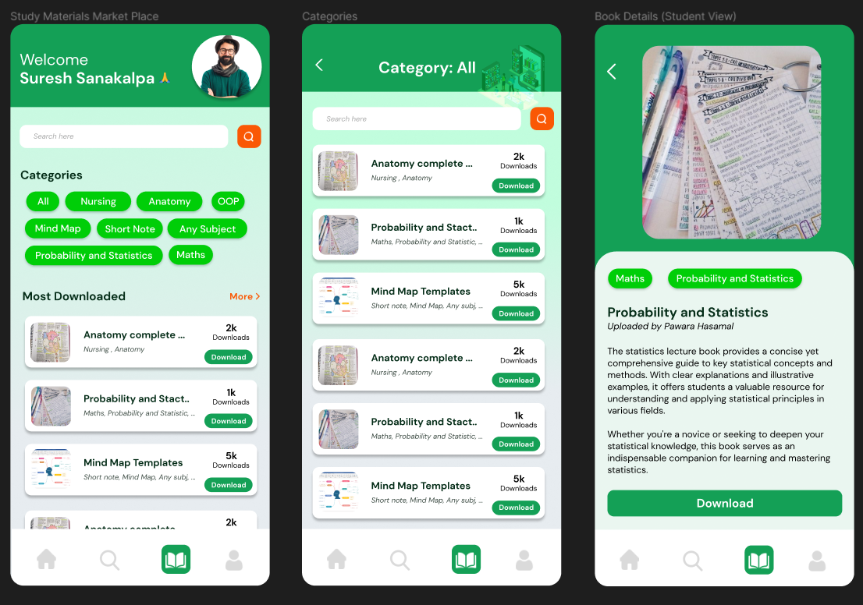

Study material Management – View all study materials, Add study materials, Edit & Delete study materials – (User role: Tutor)

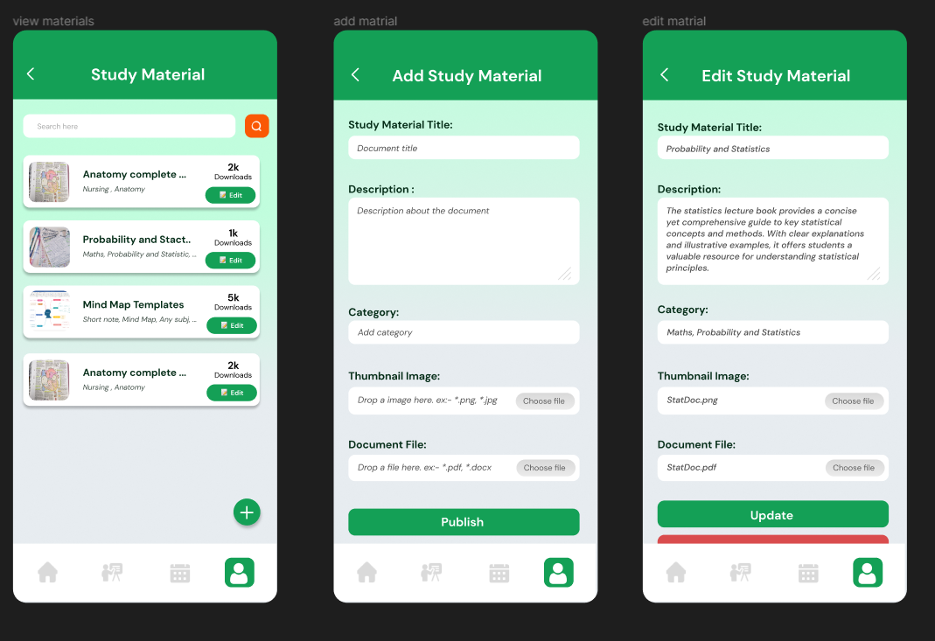

IT21291364: Tutor Management, Calendar, Login

Tutor Management – Tutor sign up, Tutor account, Tutor profile, Edit Tutor profile. – (User role: Tutor)

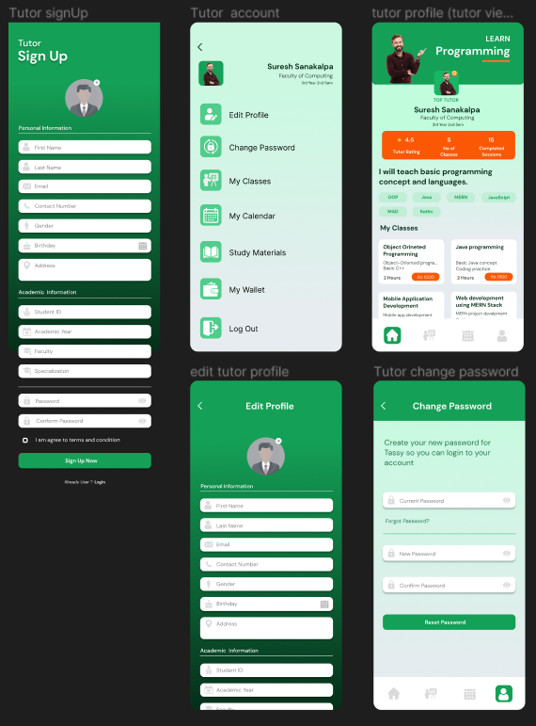

Tutor Management – View and Search Tutor. (User role: Student)

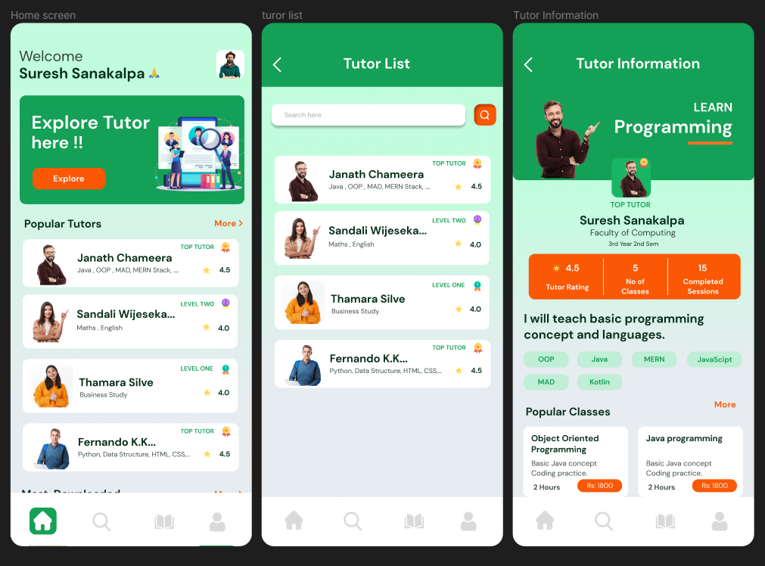

Calendar – (User role: Tutor)

Login – Forgot password, login (User: Tutor)

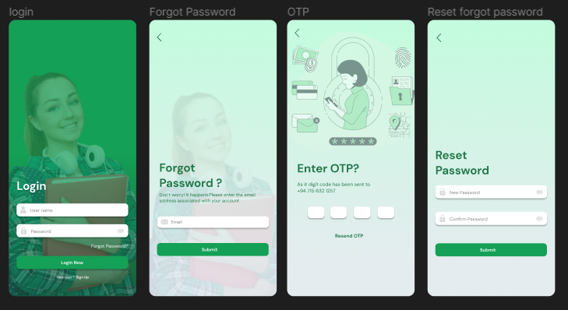

IT21388934: Class Management

Class Management – View classes, Add class, Edit & Delete class – (User role: Tutor)

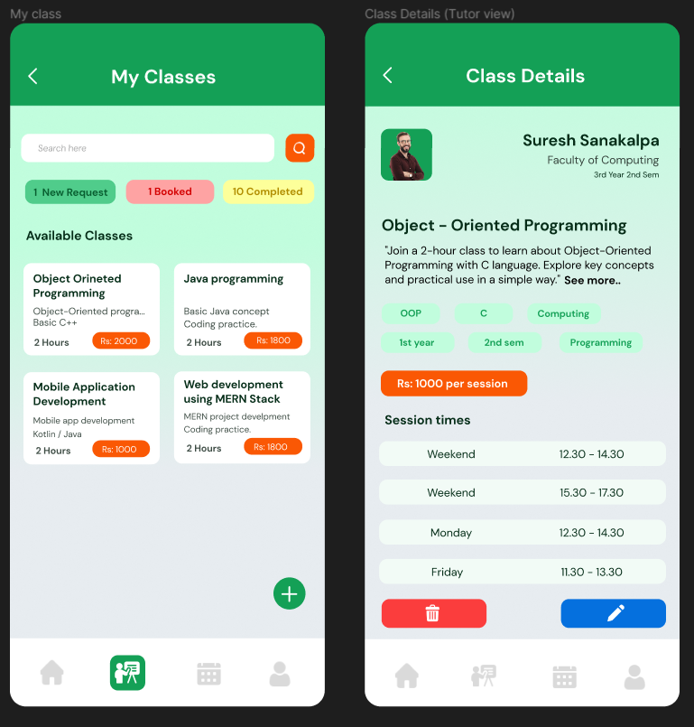

Add class, Edit & Delete class – (User role: Tutor)

Class Management – New Request and Booked Classes view, Decline new request– (User role: Tutor)

Class Management – Decline popup– (User role: Tutor)

Class Management – Student Session View – (User role: Student)

IT21267772: Request class and booking, Withdrawal, Payment Options.

Request and booking – Search classes, Request class, Book class – (User role: Student)

Payment Options – Add payment option, View payment options – (User role: Student)

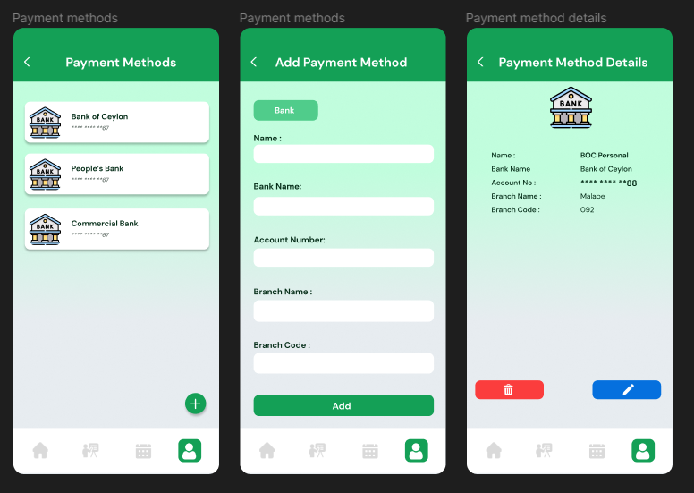

Withdrawal– Tutor wallet and Withdrawal (User role: Tutor)

Figma Prototype with interaction.

* Please be kind enough to refer to the complete prototype.

<https://www.figma.com/file/BPs3YBFWPxrInxWtXNTfMH/TutorMe?type=design&node-id=0-1&mode=design&t=K8DLdL03gNRmdlyQ-0>